ANGULAR 2

1_Introduction to Angular 2

2_Setting up Angular 2 in Visual Studio

3_Run angular 2 app using f5 from visual studio

4_Angular 2 Components

5_Angular template vs templateurl

6_Angular 2 nested components

7_Styling angular 2 components

8_Angular interpolation

9_Property binding in Angular 2

10_html attribute vs dom property

11_Angular attribute binding

12_Class binding in angular 2

13_Style binding in angular 2

14_Angular2 Event Binding

15_Two way data binding in angular 2

16_Angular ngFor directive

17_Angular ngFor trackBy

18_Angular pipes

19_Angular custom pipe

20_Angular 2 container and nested components

21_Angular component output properties

22_Angular component output properties

23_Interfaces in Angular 2

24_Angular component lifecycle hooks

25_Angular services tutorial

26_Angular and ASP NET Web API

27_Angular 2 http service tutorial

28_Angular 2 http error handling

29_Using Bootstrap with Angular 2

30_Angular 2 routing tutorial

31_Angular 2 route parameters

32_Angular dependency injection

33_Why dependency injection

34_Angular singleton service

35_Angular Injector

36_Angular root injector

37_Angular router navigate method

38_Promises in angular 2 example

39_Angular promises vs observables

40_Observable retry on error

41_Angular observable unsubscribe

42_Difference between Angular JS, Angular 2 and Angular 4

43_Angular 2 course wrap up and what's next

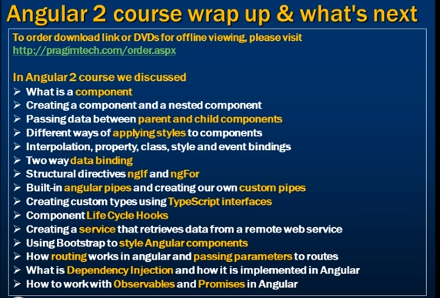

ANGULAR CRUD (Angular 5)

1_Angular project setup

2_Reading data in angular

3_Angular routing and navigation

4_Angular base href

5_Angular forms tutorial

6_Bootstrap radio buttons in Angular

7_Angular radio button checked by default

8_Bootstrap checkbox in angular

9_Angular bootstrap select list

10_Angular select options from array

11_Angular datepicker tutorial

12_Customise ngx bootstrap datepicker

13_Angular ngif directive

14_Angular disable browser validation

15_Angular form validation

16_Displaying angular form validation error messages

17_Model binding in angular template driven forms

18_Angular email validation example

19_Angular regular expression validation

20_Angular radio button validation

21_Add required attribute dynamically in angular

22_Angular checkbox validation

23_Angular select list validation

24_Angular value vs ngvalue

25_Angular custom validator example template driven forms

26_Angular select list required custom validator

27_Angular password and confirm password validation

28_Angular trigger validation manually

29_Angular form group validation

30_Angular 5 services tutorial

31_Create operation in angular

32_Angular switch case example